00000000000000000000000000000000000000000000000000000000000000000000000000000000000000000000000000000000000000000000000000

JC Rupe

Date: **June 14, 2017**

Version: **1.0.2**



**Project JIM:**

*Document Management*

**IT Project Management Office**

Document Revisions

|  |  |  |
| --- | --- | --- |
| Date | Version Number | Document Changes |
| 2016/12/16 | 1.0.0 JC | Document initial creation/completion. |
| 2017/01/03 | 1.0.0 JC | Edited a small amount of the wording. Section 1.1. |
| 2017/01/12 | 1.0.1 JC | Added references to “Customer Service Reference Guide”. Section 1.1 |
| 2017/01/17 | 1.0.1.1 JC | Added document name to footer. |
| 2017/06/14 | 1.0.2 | Bring document up to date, change name from EDEN to JIM. |
|  |  |  |
|  |  |  |
|  |  |  |
|  |  |  |

Contents

1 Document Management 3

1.1 Important Information 3

1.2 Setup a Move Document Folder 4

1.3 Drag-And-Drop – Upload a Document for a Move 5

1.4 Add – Upload a Document for a Move 7

1.5 Scanning Document(s) 9

1.6 Edit an Uploaded Document 9

1.7 Delete an Uploaded Document 10

1.8 Replace an Uploaded Document 11

# Document Management

This document explains how to upload documents to a Move.

## Important Information

* **Selecting a record, not a link in the record:** Try to select a part of the record line that doesn’t contain a link. Remember, text displayed in blue is a link. If you click on the link, it will open that items information page. For example if you select the name of the Contact, the Contact information page in JIM will open. If this happens, you may have to navigate back to the previous page or close the window that opened when you selected the link.
* The preferred browser to use is Microsoft Explorer, although, Chrome and Firefox should also work.
* For assistance with record table view navigation, see the steps in section “Navigation of a Record View” section of the “JIM – Customer Service Reference Guide” document.
* For assistance with searching and filtering of records, see the steps in section “Search & Filter Record View” section of the “JIM – Customer Service Reference Guide” document.

## Setup a Move Document Folder

1. Navigate to the Move page.
   1. Access the Main menu, by selecting the first expansion arrow in the left part of the heading line.
   2. Select the “Service” Work Area.
   3. Locate and select the “Moves” icon under the “Extensions” column.

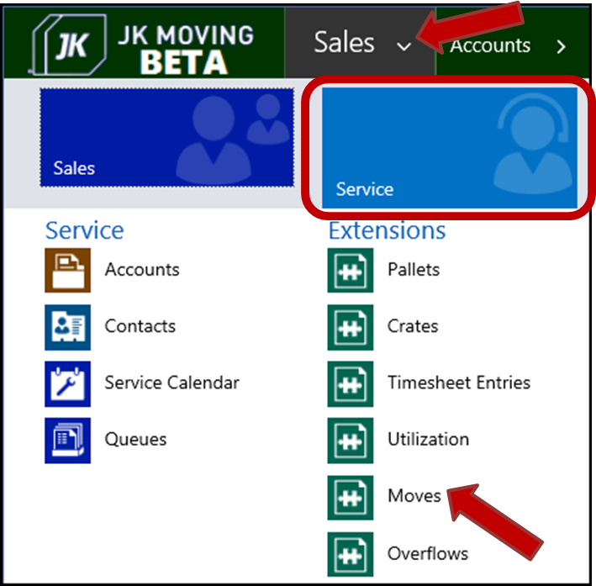

* 1. The default “Active Moves” page will appear.
  2. Enter search criteria to locate the desired Move.

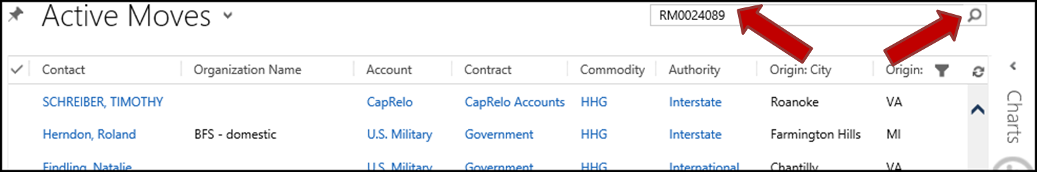

* 1. Open the found Move record, by double clicking on the Move record.

1. The “Move” page will display.
2. Select the dropdown arrow to the right of the Move name, in the top navigation bar.
3. Select the “Documents” option, from the dropdown menu.

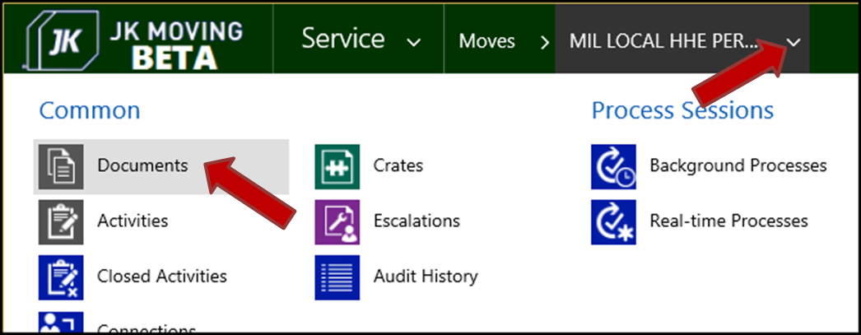

1. A folder creation message window will display.
   1. Select the “OK” button.

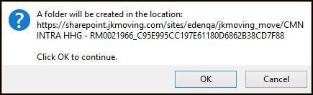

* 1. A folder is now created, in SharePoint, to hold documents uploaded for this specific Move.

1. The Move “Document Locations” page will display.
   1. The Document table grid will be empty and say “No documents are available”.

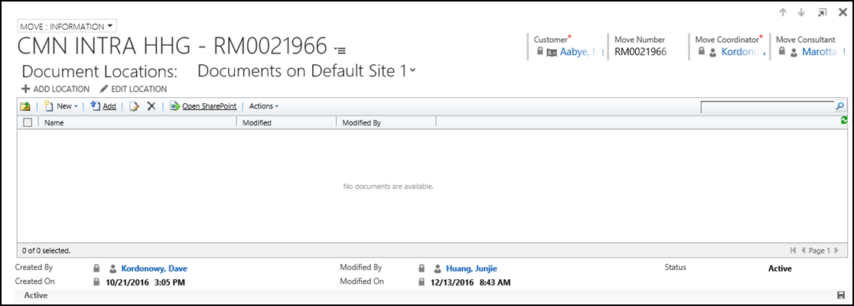

## Drag-And-Drop – Upload a Document for a Move

This section shows how to drag-and-drop documents for a Move.

**Note:** There is no way to drag-and-drop directly from an email to the Move. The files must first be taken from the email and placed into a folder or onto your desktop. Then they may be drag-and-dropped from the folder/desktop to the Move.

1. If the documents to be uploaded to the Move are in an email, take them from the email and place them in a folder on your computer.
   1. Leave the folder containing the files open.
2. Navigate to the Move “Document Locations” page.
3. Select the “Open SharePoint” link.

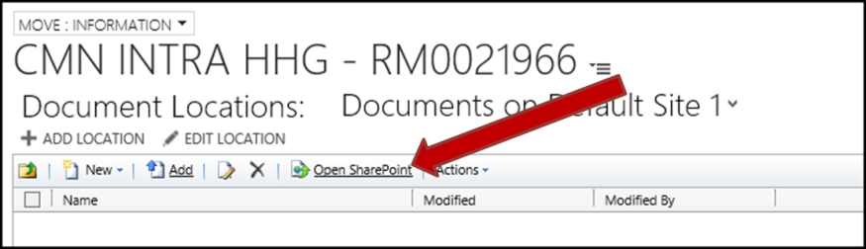

1. SharePoint will open on a new Explorer tab.
2. Files that have already been uploaded, for this Move, will be displayed.

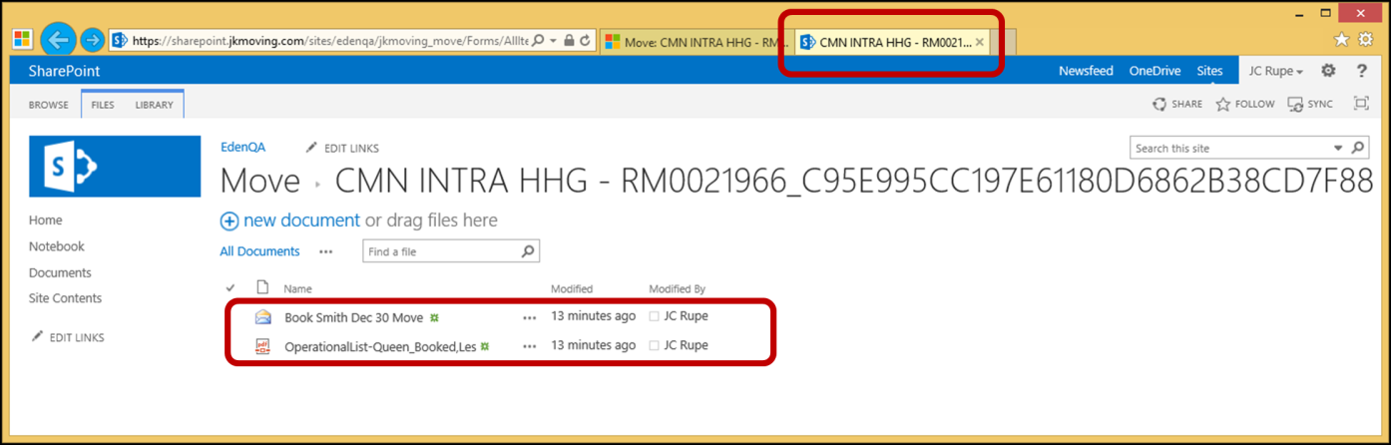

1. Drag-and-drop the files from the folder to SharePoint.
   1. As you hover over the SharePoint location, a box will open saying “Drop here…”
      1. **Note:** If you don’t drop the file(s) within this box, one of the dragged files will simply open and display its contents.
      2. **Note:** Be patient, depending on the size of the file being uploaded, this may take from a few seconds to much longer.

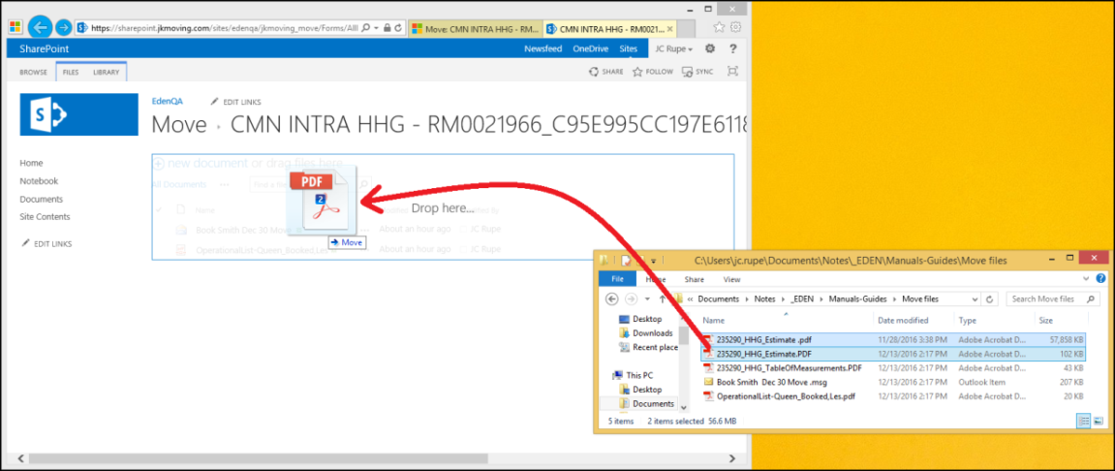

1. The file(s) will now be displayed in the SharePoint folder, once successfully drag-and-dropped.

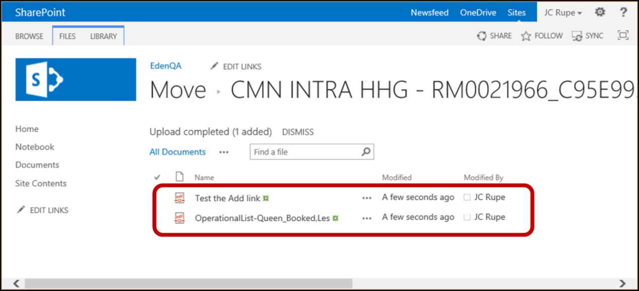

1. Close the SharePoint tab.
2. Refresh the Move “Document Locations” page.
   1. The uploaded file(s) are displayed.

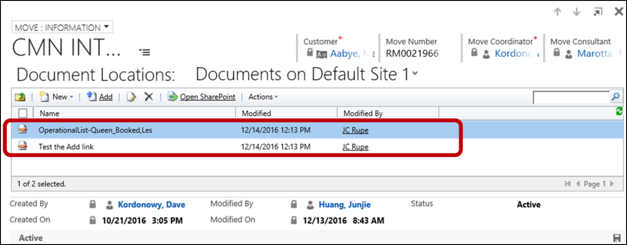

1. Disposition of the Move files placed on your computer.
   1. If you dragged the Move files to your desktop you may want to delete them.
   2. If you used a folder to hold the Move files, you may want to delete them from the folder.

## Add – Upload a Document for a Move

This section shows how to Add a document from your computer, one at a time.

1. If the documents to be uploaded to the Move are in an email, take them from the email and place them in a folder on your computer.
   1. Write down the folder location.
   2. This folder may now be closed.
2. Navigate to the Move “Document Locations” page.
3. Select the “Add” link.

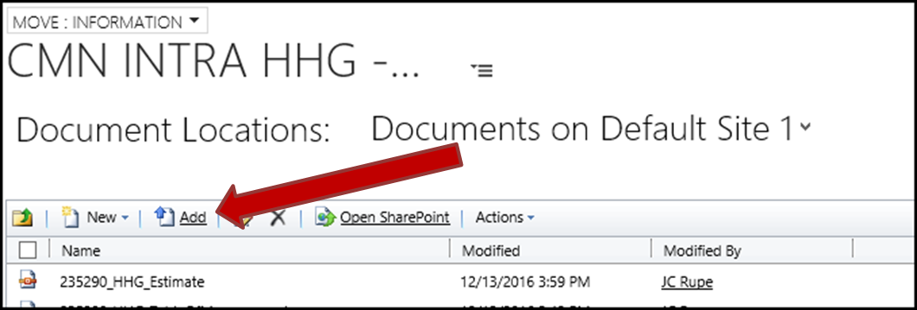

1. The “Add Document(s) – Webpage Dialog” window will open.

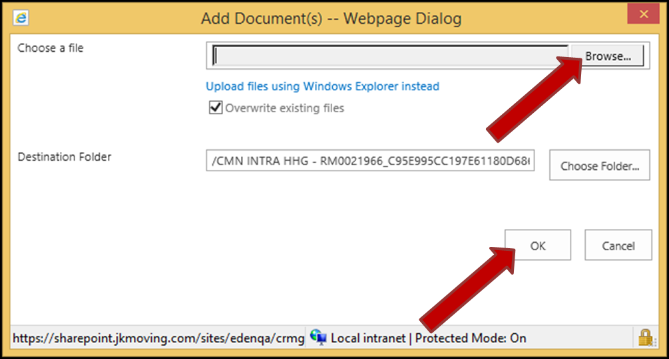

1. Upload the desired file.
   1. Select the “Browse” button to locate and select the file to be uploaded.
      1. The “Choose a File” field will populate with the files current location and name.
   2. Select to “Overwrite existing files” by placing a check in the check box.
      1. You may choose not to overwrite existing files by removing the check from the check box.
      2. For more information see section Replace an Uploaded Document, in this document.
   3. Leave the “Destination Folder” alone.
      1. Destination Folder – This is auto-populated with the Moves document location set-up by the system.
      2. **Note:** Only special circumstances may require that this be changed for an upload.
      3. **Important:** Do not set the destination folder to a folder on your computer.
   4. Select the “OK” button.
   5. The “Add Document(s) – Webpage Dialog” window will disappear.
   6. **Note:** Be patient, depending on the size of the file being uploaded, this may take from a few seconds to much longer.
2. Refresh the Move “Document Locations” page.
   1. The newly added document will be displayed in the table grid.

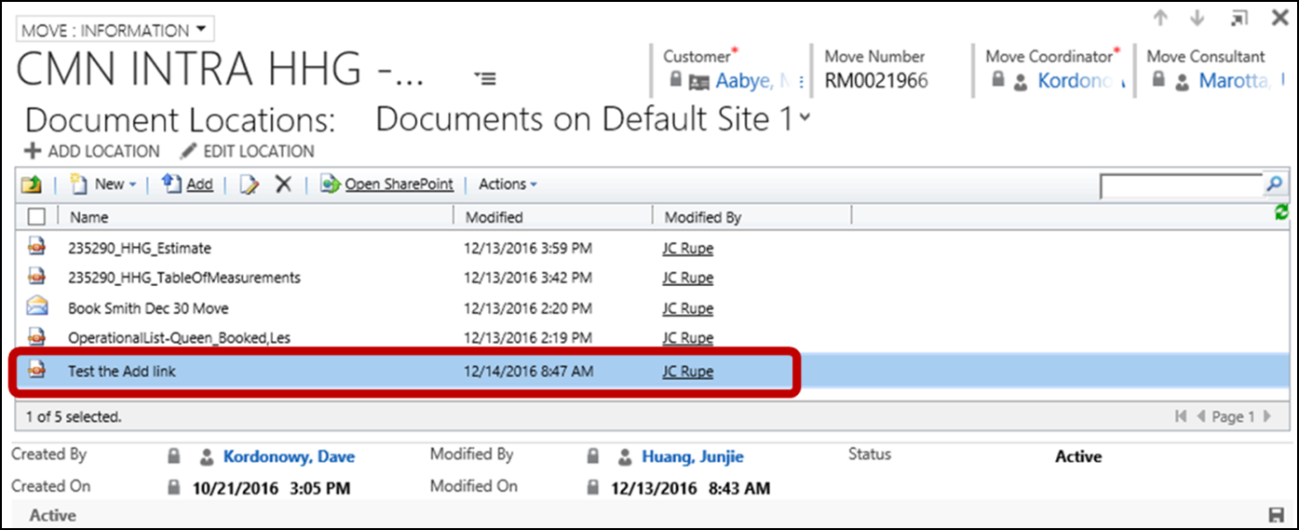

## Scanning Document(s)

The JIM system does not, at this time, support scanning documents directly into JIM. The documents must first be scanned to email(s) or file(s). From there they may be uploaded to the designated Move.

## Edit an Uploaded Document

This section shows the user how to edit an uploaded document(s) in place. Editing capabilities are dependent on the type of file. Word and Excel documents are examples.

Another editing option would be to download the desired document, edit it on your computer and then upload it to replace the existing document.

1. Navigate to the Move “Document Locations” page.
2. Select the Document to be edited.
   1. **Note:** Only one document at a time may be edited.
   2. The selected row will change color, indicating that it is selected.
3. Select the “Edit” button. 
4. The selected Document will display.
5. Edit and save the Document based on the type of document and the application that opens it.
   1. For example: Microsoft Word, Microsoft Excel and etc.
6. Reopen the Document to verify your changes.

## Delete an Uploaded Document

This path allows you to delete a document from a Move.

1. Navigate to the Move “Document Locations” page.
2. Select the Document(s) to be deleted.
   1. Select the first Document.
   2. The selected row will change color, indicating that it is selected.
   3. Select the additional Document(s) by holding the Ctrl keyboard key and clicking on the Document record(s).
   4. All selected Document record(s) will be highlighted.

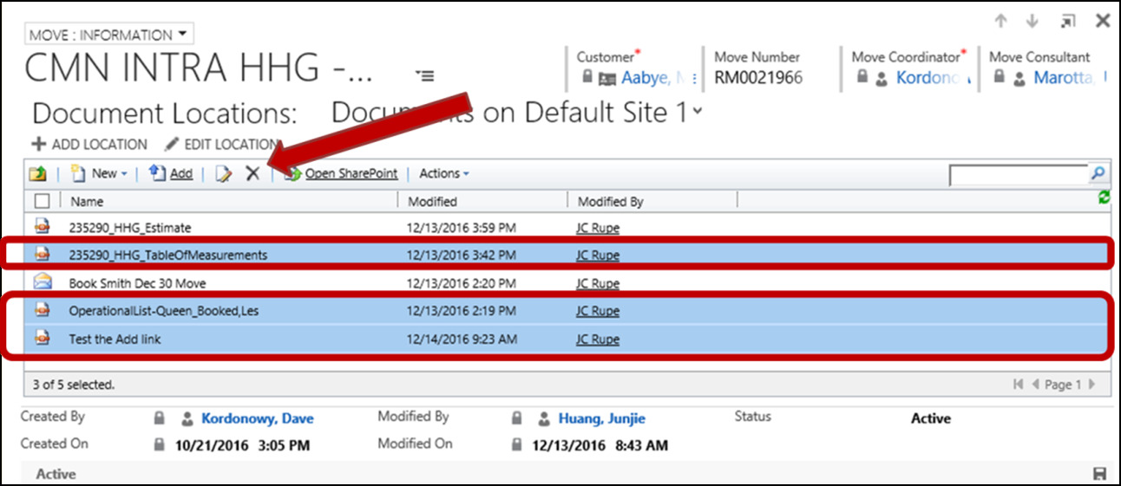

1. Select the “Delete” button. 
2. A confirmation message window will open.
   1. Select the “OK” button.

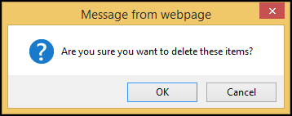

1. The deleted documents will vanish from the Moves “Document Locations” page display grid.

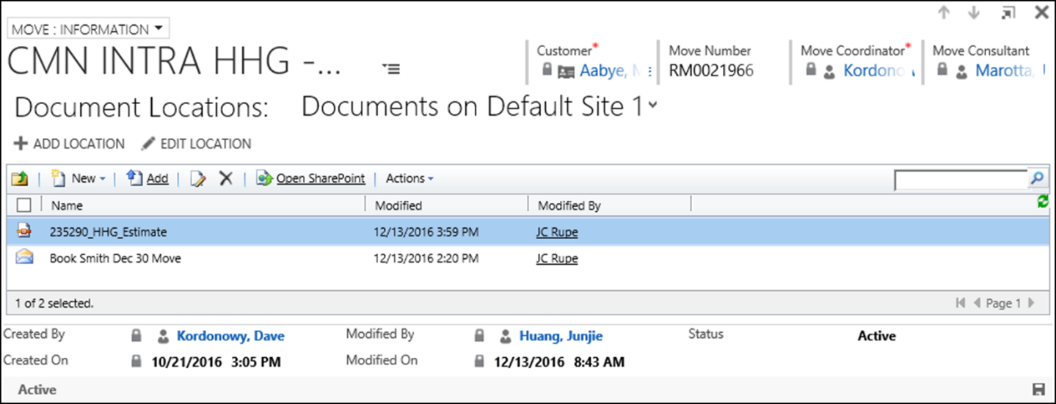

## Replace an Uploaded Document

1. Drag-And-Drop
   1. During the drag-and-drop of a file, if the same named file already exists, you have the option to replace it or not.
   2. A message window will display asking if you want to replace the file.

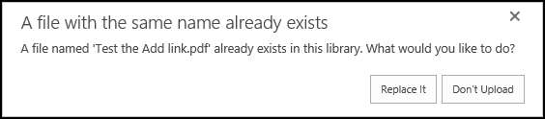

* + 1. Choosing the “Replace It” button will cause the previously uploaded document to be overwritten with the new uploaded document.
    2. Choosing the “Don’t Upload” button will stop the upload. The previously uploaded document will remain intact and untouched.
       1. Your next option here is to rename your file and upload the renamed file.

1. Add
   1. During the Add of a file, there is a check box where you may designate to “Overwrite existing files” or not.
   2. If you choose not to overwrite and attempt to upload a file with the same name as a previously uploaded document, a warning message will display.
      1. Select the “Go Back to Site” option.
      2. The upload will not be performed. The previously uploaded document will remain intact and untouched.
      3. Your next option here is to rename your file and upload the renamed file.

